Coping With Disaster: A Medical Overview

By Dr. Sudip Bose, MD, FACEP, FAAEM
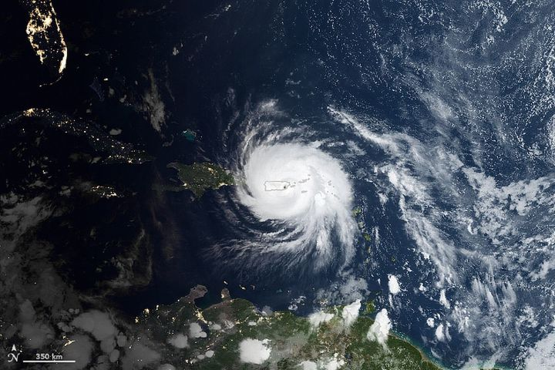
First there was Harvey, then Irma and, most recently, Maria. Hurricanes have hit Texas and the Gulf Coast, have torn through Florida, and have raked across the Caribbean, devastating Puerto Rico and the Virgin Islands. These disastrous power punches have left scores dead, millions uprooted and much physical and emotional devastation in their wake.
As of this writing, Hurricane Harvey has been reported to have caused 82 deaths; Hurricane Irma’s U.S. death toll stands at 75; and so far, Hurricane Maria has claimed 27 lives and likely will go higher. Some of those killed as a result of Irma involved nursing home patients.
How can that happen, you ask? Shouldn’t these kinds of victims have been our top priorities for keeping safe? Of course. But sometimes, all the planning and precaution in the world can’t overcome the unpredictability of Mother Nature, a disabled infrastructure and the failure of emergency backup power.
Every natural disaster, such as hurricanes Harvey, Irma and Maria, also becomes a looming public health disaster. As the storms approach, each hospital, nursing home and medical facility that houses patients must make difficult decisions between evacuating patients and staff and battening down to ride out the storm. Evacuations pose major logistical issues as patients, staff, equipment and medications all have to be transitioned from one location to another. An evacuation for a chronically or critically ill patient can be life-threatening. During the height of the storms, hospitals and other medical facilities face critical issues in trying to keep their patients not only alive, but also well cared for. Shortages of food, water, medicine and power can turn very bad very quickly.

After the Storm
After the brunt of hurricanes like Harvey, Irma and Maria push through, health resources re-focus on fighting infections, both from bacteria in floodwaters and from mosquitoes. Physicians scramble to contain potential epidemics that might arise after flooding. Based on the health problems that arose after Hurricane Katrina, medical professionals have to prepare to try to avert major public-health emergencies, environmental illnesses, and outbreaks, which could intensify in the aftermath of the devastating blows dealt by these hurricanes. Sewage that has overflowed its containment can pose a major health issue, as can spilled fuel and chemicals from tanks and pipelines torn apart during the hurricanes.
And not only that, but for hospitals and other facilities that made the decision to move patients, those same patients have to be transitioned back home to their original facilities at some point, assuming those facilities are able to open and operate again.
As you can see, there is much to consider when preparing for a natural disaster like hurricanes Harvey, Irma and Maria. In fact, the Centers for Medicare and Medicaid Services have established an Emergency Preparedness Rule that all hospitals and health care facilities must have a plan in place and be in compliance by Nov. 16, 2017. This emergency preparedness plan, by CMS guidelines, must address an all-hazards risk assessment and contain four core elements:

Four Core Elements of Emergency Preparedness
RISK ASSESSMENT AND EMERGENCY PLANNING (include but not limited to):
- Hazards likely in geographic area
- Care-related emergencies
- Equipment and power failures
- Interruption in communications, including cyber attacks
- Loss of all/portion of facility
- Loss of all/portion of supplies
- Plan is to be reviewed and updated at least annually
COMMUNICATION PLAN
- Complies with federal and state laws
- System to contact staff, including patients’ physicians, other necessary persons
- Well-coordinated within the facility, across health care providers, and with state and local public health departments and emergency management agencies.
POLICIES AND PROCEDURES
- Complies with federal and state laws
TRAINING AND TESTING
- Complies with federal and state laws
- Maintain and at a minimum update annually
The plan must also consider those individuals locally who may be deemed “at risk.” To quote from the CMS guidelines:
At-risk populations are individuals who may need additional response assistance, including ... [those] from diverse cultures, [who] have limited English proficiency, or are non-English speaking.
In addition to shelters, hospitals are often a focal point of their communities during a crisis. In addition to patients already admitted to a hospital, during a natural disaster like a hurricane, new patients are very likely to seek medical assistance by coming to the emergency department either on their own or after being rescued by a first responder. And first responders need to know the status of a hospital to ensure they’re transporting patients to an open, operating, safe medical facility. Hospitals need to work with other hospitals to know where to send or receive patients if any of the open facilities become overwhelmed. And as always, hospitals need to remain HIPAA-compliant regarding patient information; just because a hospital might be operating within a disaster doesn’t mean it can be casual or careless with personal patient information.
Once hurricanes like Harvey, Irma and Maria have passed and done their damage, the next challenge is keeping the most critically ill patients cared for. We’re seeing that now, and especially so, in Puerto Rico, which is an island. You just can’t drive trucks there loaded with food, fuel, water and medical supplies. All that has to be flown in or shipped in.

Finding Comfort
“The other challenge that we face, is unfortunately because of the severity of the hit [from Hurricane Maria] there is diminished capacity of local governments and state government to respond similar to what we saw with Texas and Florida,” said Brock Long, FEMA Administrator. “So therefore, it is requiring us to push forward a lot of resources, including the USS [sic] Comfort, which is on the way.”
The USNS Comfort is a Navy hospital ship that sails to points of distress when needed to assist medical personnel on the ground with there most dire patients and circumstances. It is heading to Puerto Rico. It has one of the largest trauma facilities in the United States. It has a supply of 5,000 units of blood, according to a U.S. Navy fact sheet about the vessel, and is equipped with a full spectrum of surgical and medical services including X-ray machines, CAT scan units, a dental office, an optometry facility, a physical therapy center and a pharmacy. The 1,000-bed ship was sent to Haiti in 2010 after a large earthquake killed upwards of 300,000 people. In 2005, the ship sailed to the Gulf Coast after Hurricane Katrina hit and more than 1,500 people were treated aboard the vessel. In 2003, the hospital ship spent two months in the Persian Gulf during the invasion of Iraq, and it also was deployed to New York in the aftermath of 9-11.
Getting medical support to areas ravaged by these hurricanes and other natural disasters can be formidable. The news media may leave these areas after the initial news is reported and the days march on; however, the support needed for medical personnel, supplies and treatment carries on for months until the area stabilizes.
Right now in Puerto Rico, according to a report by Reuters, “For hospitals across this region, the challenges are mounting. After the power went out, back-up generators at some hospitals failed quickly. Other hospitals are running critically low on diesel. Fuel is so precious that deliveries are made by armed guards to prevent looting, according to Dr. Ivan Gonzalez Cancel, a cardiovascular surgeon and director of the heart transplant program at Centro Cardiovascular,” the report said.
People line up for blocks trying to get enough fuel to power generators and vehicles, waiting for sometimes up to seven hours. Everything else there is in a shambles as well, adding to the urgency and stress. Food is scarce. The island’s electrical grid has gone down and may stay that way for months.
“Cellular service, internet, and email have virtually disappeared, hurling a modern society into a bygone era,” Reuters reported. “Radio has become a primary source of information.”
For hospitals that need to transfer critical patients because they can’t support them due to lack of electricity, the situation is dire. For them, the USNS Comfort can’t arrive fast enough. If necessary, the most critical patients can be evacuated via medevac and transferred to the USNS Comfort while it’s still underway and sailing towards Puerto Rico.
And in the meantime, if medical staff on the island can’t get gasoline for their cars, how can they even get to work to care for the sick and injured?
FEMA’s Twitter feed has been carrying photos of ongoing efforts in Puerto Rico: The American Red Cross is on the scene, as is the Salvation Army, U.S. state urban search and rescue teams, the National Guard, Customs and Border Protection is assisting, the U.S. Coast Guard, the U.S. Navy, Veterans Administration medical centers are supporting by taking in evacuated patients … it goes on and on. The effort is just massive and won’t end anytime soon. (Also see, The Guardian: Photos After Hurricane Maria)

Getting Help
All these areas – Texas with Hurricane Harvey, Florida with Hurricane Irma, and Puerto Rico with Hurricane Maria – need our continued help and support on a variety of fronts. And we also should not forget those suffering in Mexico, which was hit recently with major earthquakes resulting in a death toll of at least 333 people and counting. Here are some links and suggestions for ways you can donate, if you are moved to do so, culled from relief websites and media:
- American Red Cross
- DirectRelief.org – Humanitarian Medical Aid
- NY Times: How to Help
- USA Today: How You Can Help
- Business Insider: Best Charities to Help
- NBC News: How to Help Storm Victims
Those are just a handful of entry points for support and donations and sources for helping victims. Use your discretion for any donation should you decide to help out. Let’s hope these areas get the continued support they desperately need.

https://www.huffpost.com/entry/coping-with-disaster-a-medical-overview_b_59cc381de4b0b99ee4a9ca66

